Lê Ngọc Hảo -22683241 - TH - KTTKPM - Lab01 - 20/01/2026
curl -X POST http://localhost:3000/send \
-H "Content-Type: application/json" \
-d '{"message":"Order #1000 send"}'

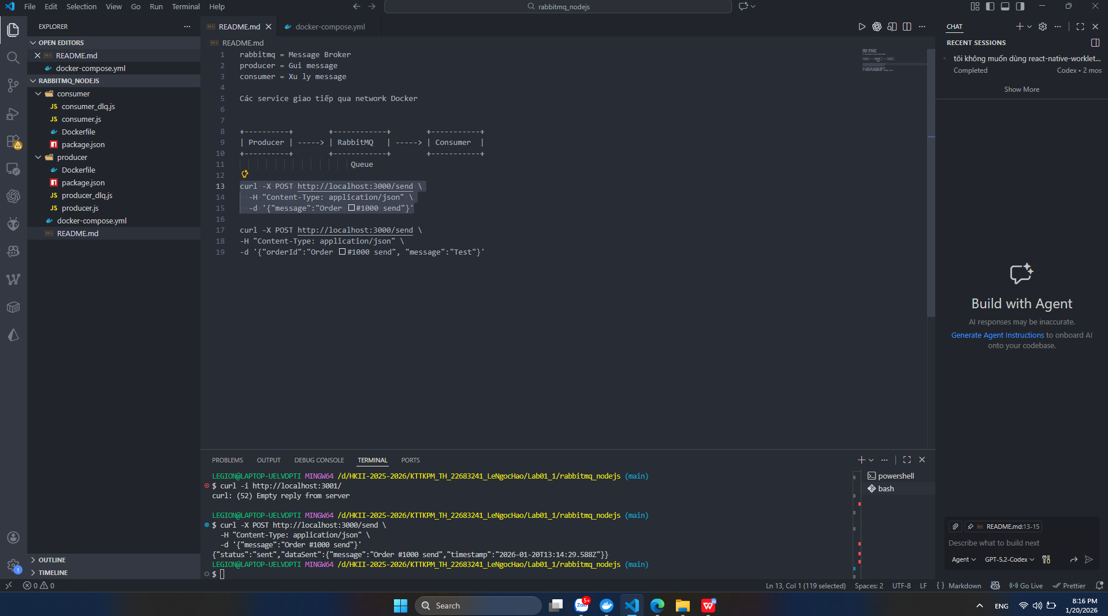
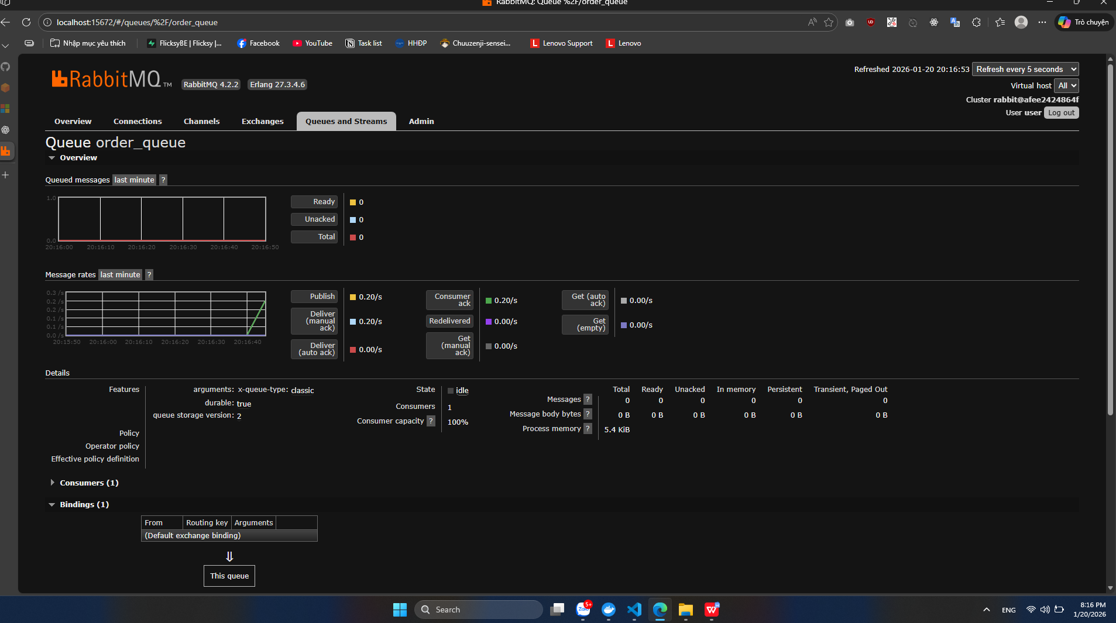

curl -X POST http://localhost:3000/send \
-H "Content-Type: application/json" \
-d '{"orderId":"Order #1000 send", "message":"Test"}'
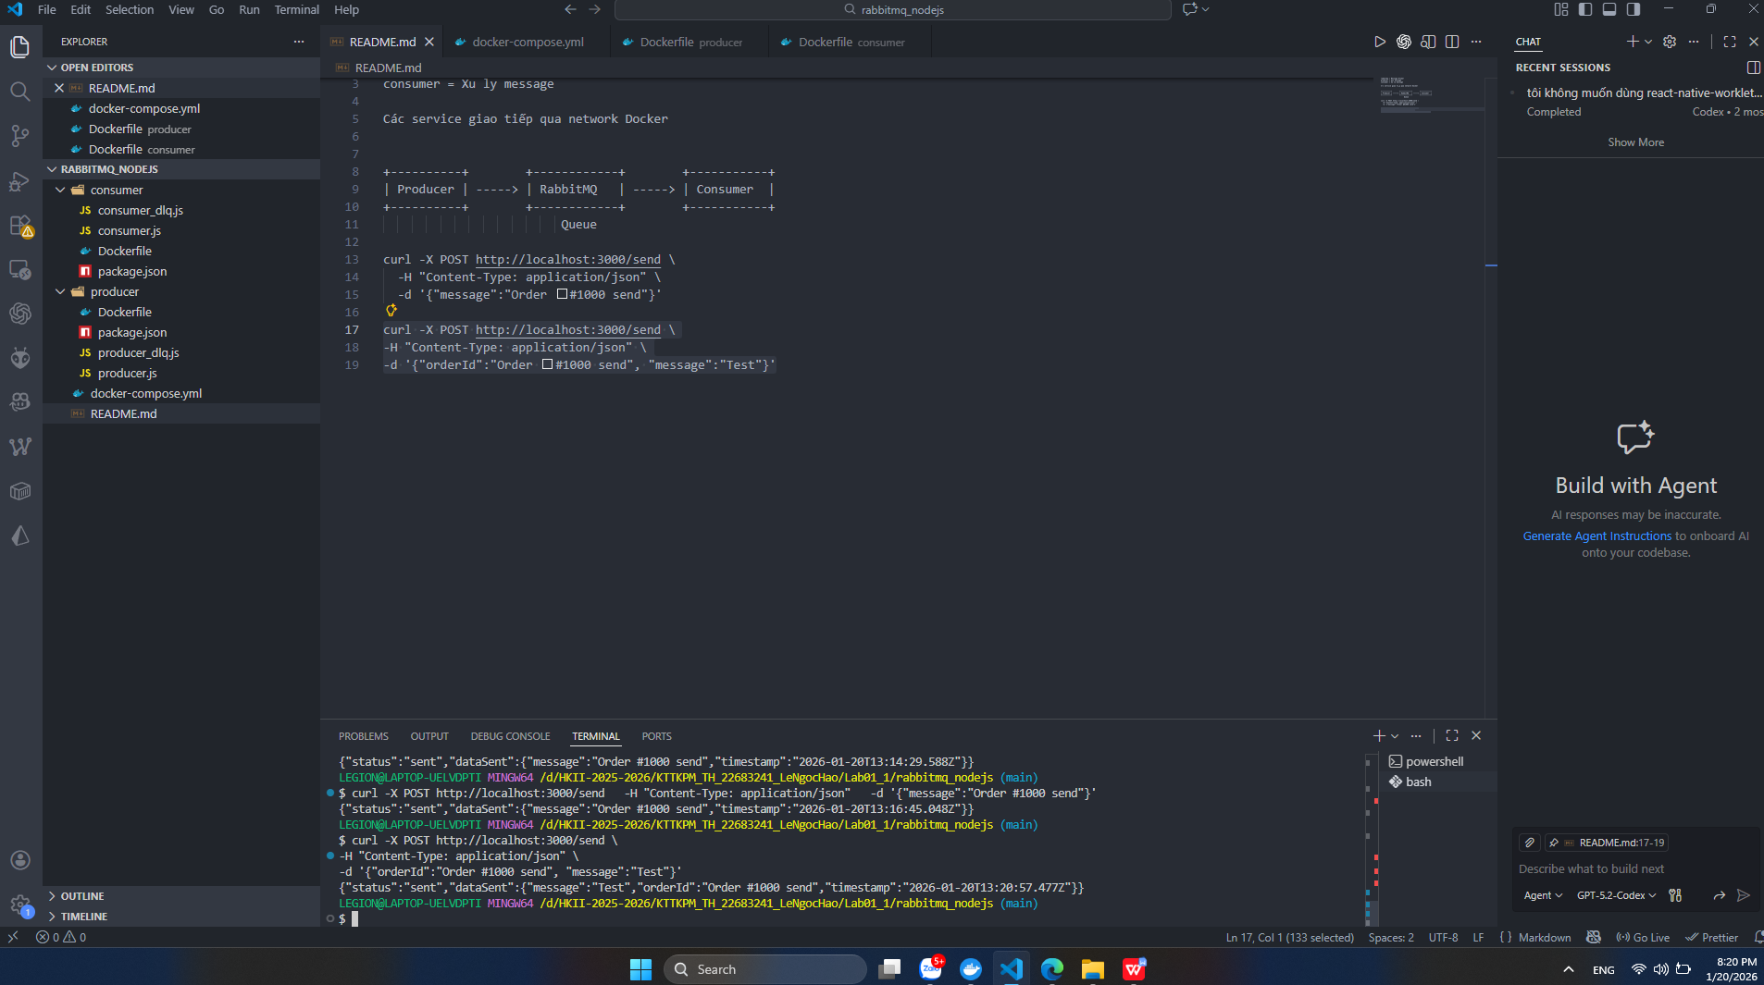
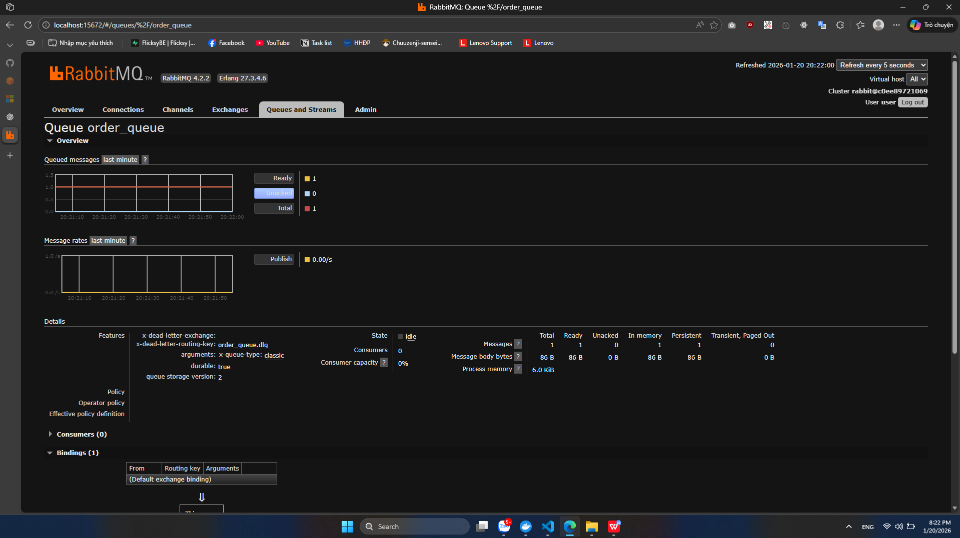

curl -X POST http://localhost:3000/send \
-H "Content-Type: application/json" \
-d '{"message":"Test"}'
